Spring boot

1. What is Spring boot ? 1

1.1 Features of spring boot 1

1.2 Difference between Spring and Spring boot 2

1.3 Features of spring boot 2

1.4 Features of spring boot 2

2 MAVEN 2

3 MAVEN 2

3.1 What is Maven? 2

3.2 Meven Objectives 3

# What is Spring boot ?

Spring boot is a java-based spring framework used for Rapid Application Development (to build standalone micro services).

It has extra support of auto configuration and embedded server applications like tomcat, jelly etc.

Provides large number of helper classes and annotations

## Features of spring boot

Minimizes the amount of manual configuration.

Makes it easier to get started with spring development.

Performs auto configurations based on JARS and props files

Resolve dependency conflicts (maven and gradle).

Provides an embedded HTTP server so you can get started quicker.

It has embedded tomcat, jetty which makes it just code and run application.

Provides production ready application.

Absolutely no requirement of XML Configuration.

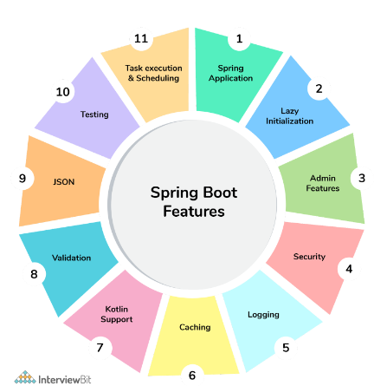

## Difference between Spring and Spring boot

|  |  |  |
| --- | --- | --- |
| S.No. | Spring | Spring Boot |
| 1. | Spring is an open-source lightweight framework widely used to develop enterprise applications. | Spring Boot is built on top of the conventional spring framework, widely used to develop REST APIs. |
| 2. | The most important feature of the Spring Framework is dependency injection. | The most important feature of the Spring Boot is Auto configuration. |
| 3. | It helps to create a loosely coupled application. | It helps to create a stand-alone application. |
| 4. | To run the Spring application, we need to set the server explicitly. | Spring Boot provides embedded servers such as Tomcat and Jetty etc. |
| 5. | To run the Spring application, a deployment descriptor is required. | There is no requirement for a deployment descriptor. |
| 6. | To create a Spring application, the developers write lots of code. | It reduces the lines of code. |
| 7. | It doesn’t provide support for the in-memory database. | It provides support for the in-memory database such as H2. |
| 8. | Developers need to write boilerplate code for smaller tasks. | In Spring Boot, there is reduction in boilerplate code. |
| 9. | Developers have to define dependencies manually in the pom.xml file. | pom.xml file internally handles the required dependencies. |

## Features of spring boot

## Features of spring boot

# MAVEN

# MAVEN

## What is Maven?

* It is a tool for project Management and build automation
* Licensed by Apache software foundation
* Maven features such as
  + Build tool capabilities
  + Run reports
  + Generate a website
  + **Dependency Management**
  + Repositories (Reusable Plugins)
  + Continuous integration build system
  + Portable
  + Building configuration using maven are portable to another machine without efforts

**Note: -**

* **Maven is not a programming language**
* **It's not a framework**
* **It's not a library**
* **It's not an environment**

## Meven Objectives

* Makes the development process visible or transparent
* Provide an easy way to see the health and status of a project
* Decreases training time of new developers
* Preventing inconsistent setups
* Providing a standard development infrastructure
* Focus energy on writing code of application

Completed 30.00 of 1st lecture LMS

References:-

https://github.com/darbyluv2code/spring-boot-3-spring-6-hibernate-for-beginners